JDBC lab (PM)

The “RBS Data Export” GUI has Buttons and TextFields as shown below:

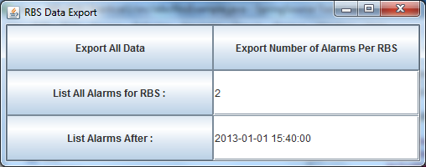

Using the Java implementation provided, complete the actionPerformed() method for each of the following buttons

1. exportButton – **“Export All Data”** , queries the database and writes all the data from the table to a CSV file.
2. alarmsperRBSButton - **“Export Number Alarms Per RBS” ,**  queries the database and writes the number of alarms per RBS to a CSV file.
3. allAlarmsforRBSButton – **“List All Alarms for RBS : " ,** queries the database and writes all the alarms for the specified RBS to a CSV file.

In the above example RBS 2 is specified, so the output to file is as follows:

Alarm_Number,RBS_ID,Alarm_Description,Date,Priority

1,2,Overheated Unit, 01/01/2013 12:40:00,2

4,2,Overheated Unit, 01/01/2013 16:10:00,2

1. alarmsAfterButton - **"List Alarms After :",** queries the database and writes all the data for alarms after the specified time to a CSV file

In the above example 2013-01-01 15:40:00 is specified, so the output to file is as follows:

Alarm_Number,RBS_ID,Alarm_Description,Date,Priority

4,2,Overheated Unit, 01/01/2013 16:10:00,2

5,3,Overloaded Unit, 01/01/2013 16:31:12,1

6,3,Overloaded Unit, 01/01/2013 17:31:12,1